**Push an Image to Docker Hub**

FROM python

WORKDIR /app

ADD . /app

RUN pip install -r requirements.txt

EXPOSE 80

ENV NAME world

CMD [“python”, “app.py”]

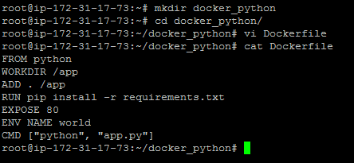

from flask import Flask

import os

import socket

app = Flask(__name__)@app.route(“/”)def hello():

html = “<h3>Hello {name}!</h3>” \

“<b>Hostname:</b> {hostname}<br/>”

return html.format(name=os.getenv(“NAME”, “world”), hostname=socket.gethostname())

if __name__ == “__main__”:

app.run(host=’0.0.0.0', port=80)

